PRESS INFO: INTERSOLUTION 2024
Ghent (Belgium), January 2024

Innovation in the spotlight at 12th edition of InterSolution
More than 130 international exhibitors spread over 10,000 m2 at solar trade fair for the Benelux
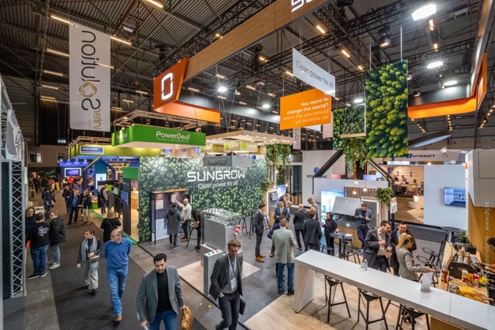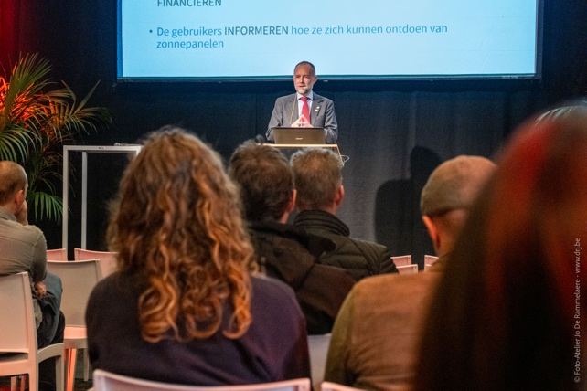

With more than 130 international exhibitors and no fewer than 5,228 visitors, InterSolution confirmed its position as the leading platform for the solar industry at Ghent’s Flanders Expo on 17 and 18 January. The solar industry’s main suppliers and manufacturers from all over the world filled a single well-laid-out exhibition hall measuring a generous 10,000 m2 – an expansion of 30% over the previous year! – as they presented their innovative inverters, batteries, charging systems, solar panels, solar cells, mounting systems and related products to the Benelux market. Most of the visitors were obviously from Belgium. 16% of the professionals present were from the Netherlands.

Since InterSolution is the first trade fair of the new year for many participants, it offers visitors a good impression of the innovations in store for 2024 regarding the market for solar panels, converters, batteries, charging solutions, mounting systems, control techniques, software and monitoring. The show floor reflected the industry’s continuing development. With all the major international players present such as Qcells, SMA Benelux, Belga Solar, Wienerberger, SolarEdge, Esdec, SolaX Power Network Technology, Sungrow Benelux, Shenzhen Growatt New Energy, GoodWe, Niko, Battery Supplies, Duracell Energy, Schäfer+Peters, Schletter Solar, Mounting Systems, Regitec Solar and many more, InterSolution once again served as an important place for professionals to meet and share knowledge, set up partnerships and explore new leads.

Quality prevails

Delphine Martens, Exhibition Manager: "The solar market continues to evolve at a rapid pace thanks to all the challenges coming our way due to the energy transition. InterSolution once again offered a comprehensive overview of the latest current and future solutions for inverters, batteries, charging systems, energy storage, solar panels and solar collectors. Despite the fact that this 12e edition had been enlarged by more than a quarter compared to the previous one, the quality of both participating companies and visitors continued to win out over quantity.”

Masterclasses

Besides exploring exhibitors’ stands, visitors at the two-day networking and trade fair could also attend free master classes. This year, more than 20 master classes were available from exhibitors including Elicity, Esdec, Fox ESS Netherlands, Fronius International, GPC Europe, LIFEPOWR, Phoenix Contact, PV CYCLE Belgium, SMA Benelux, SolarEdge and Ysebaert. There were interesting lectures on topics such as energy storage, energy management, the energy transition, monitoring and solar panel recycling. Visitors could ask questions and interact with the experts directly.

Save the date for InterSolution 2025

Considering the success of InterSolution 2024, the organisation anticipates a bright future. A growing demand for renewable energy emphasises the solar industry’s vital role, and InterSolution remains a catalyst for further developments. The next edition will take place on 29 and 30 January 2025 (with an evening opening on Wednesday). It once again promises to be a source of inspiration and innovation and the best meeting place for companies aiming to lead the way in solar energy. Interested exhibitors can register now via info@intersolution.be.

All information: www.intersolution.be

Make a note in your calendar: 13e edition of InterSolution on 29 and 30 January 2025 at Flanders Expo in Ghent

InterSolution 2024 aftermovie: https://youtu.be/CLJotbai8nQ?si=YIdWv_2r3wl2iPTc
*** NOT FOR PUBLICATION ***

Images (photos of 2024 edition) are available for download at www.intersolution.be
(Go to Press – Visual Material)

For more press information, please contact:
Kurt Peeters, press officer
M +32 (0)474 444 660
press@intersolution.be

Trade fair organisation:
Delfico BV
Maaltebruggestraat 300
9000 Ghent (Belgium)
T +32 (0)9 385 77 19
www.intersolution.be

